**Python Functions**

**Illustration of a User-Defined Function**

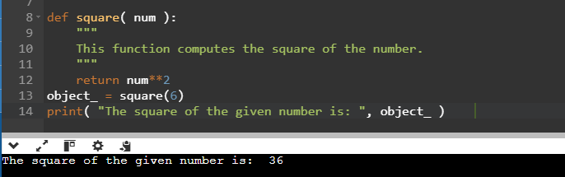

**Calling a Function**

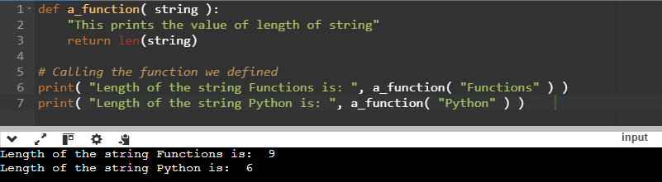

**Pass by Reference vs. Pass by Value**

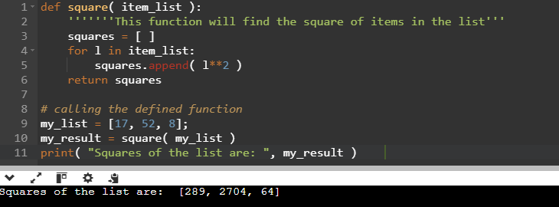

**Function Arguments**

**1) Default Arguments**

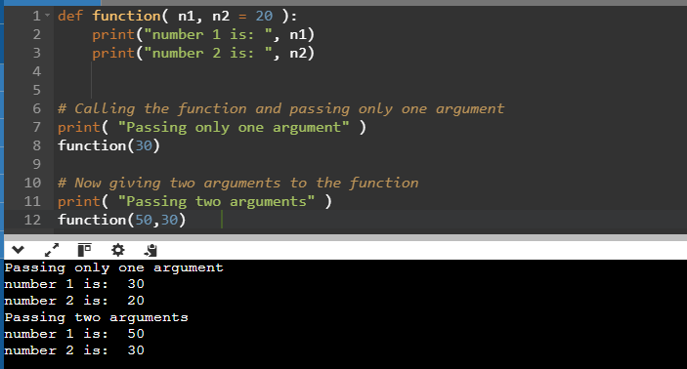

**2) Keyword Arguments**

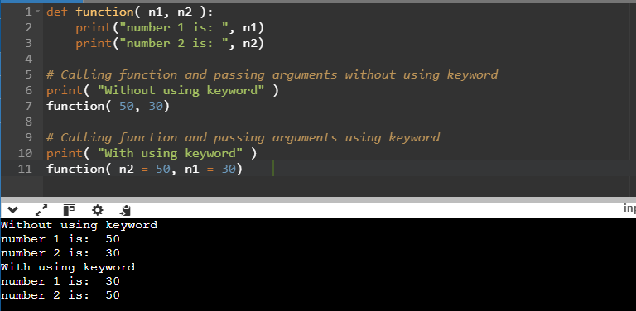

**3) Required Arguments**

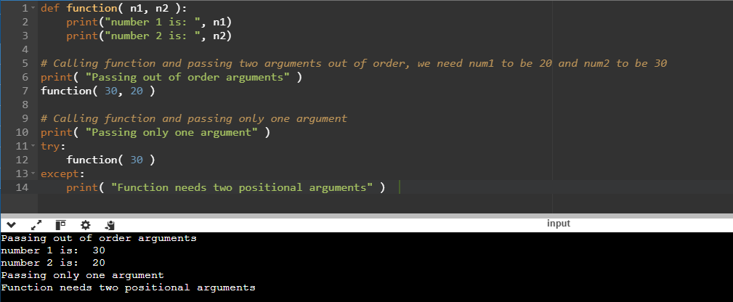

**4) Variable-Length Arguments**

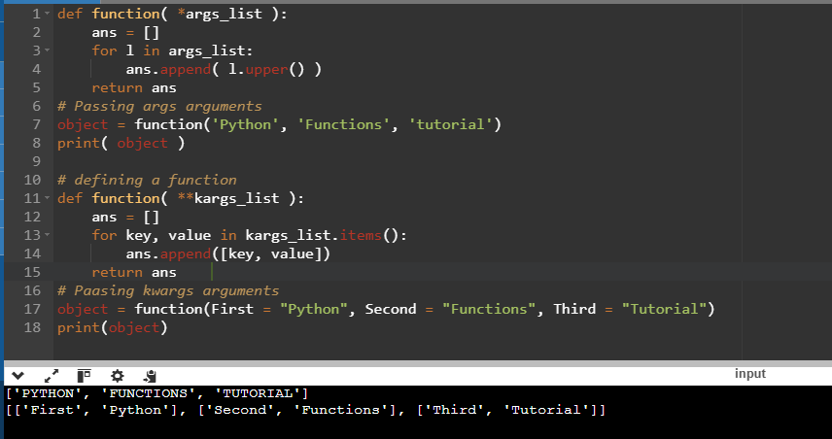

**return Statement**

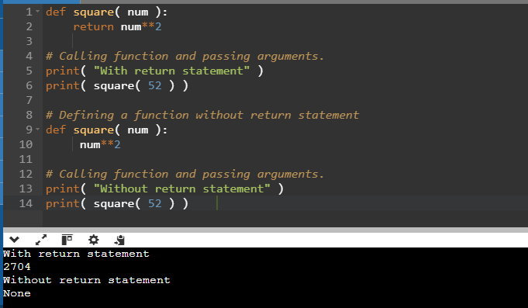

**The Anonymous Functions**

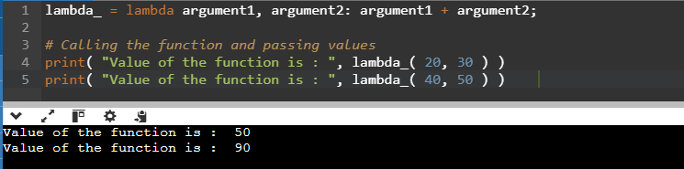

**Scope and Lifetime of Variables**

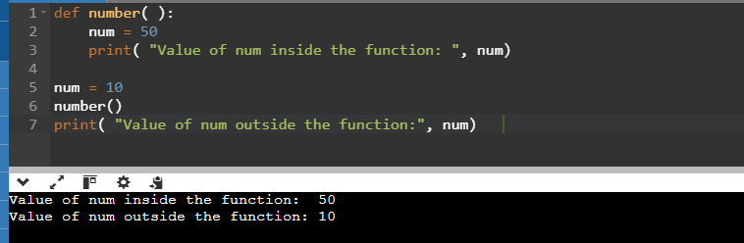

**Python Capability inside Another Capability**

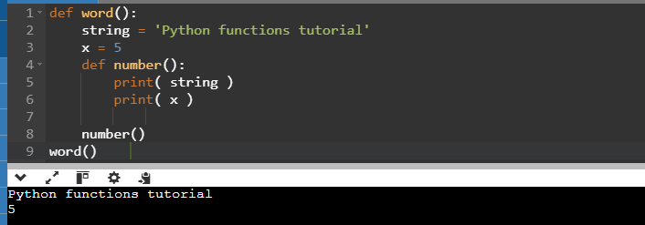

**Python Built-in Functions**

**Python abs() Function**

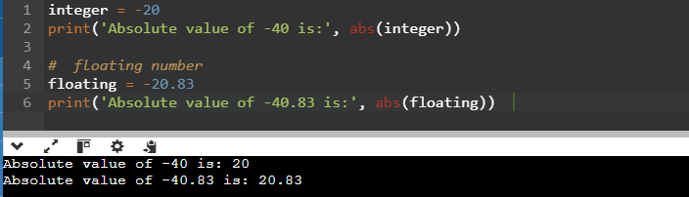

**Python all() Function**

**Python all() Function Example**

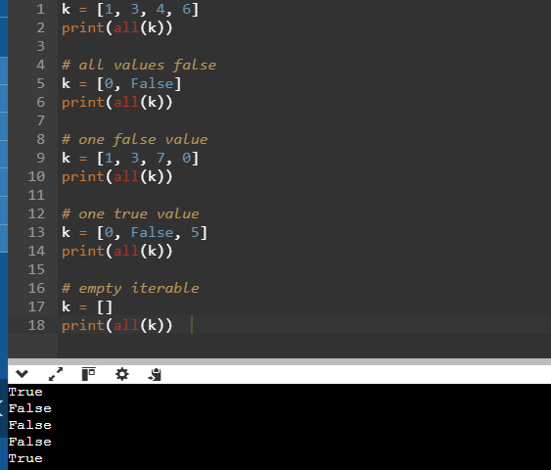

**Python bin() Function**

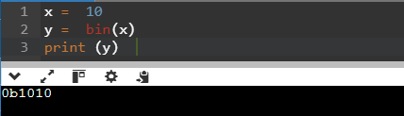

**Python bool()**

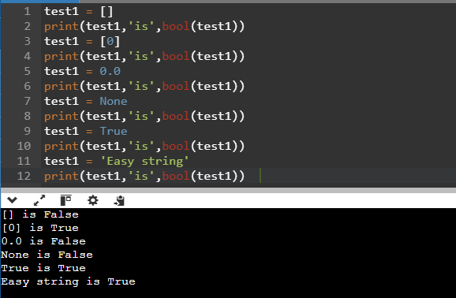

**Python compile() Function**

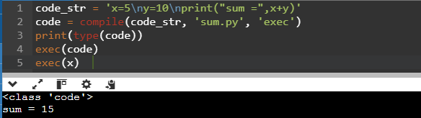

**Python exec() Function**

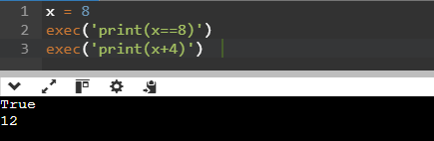

**Python any() Function**

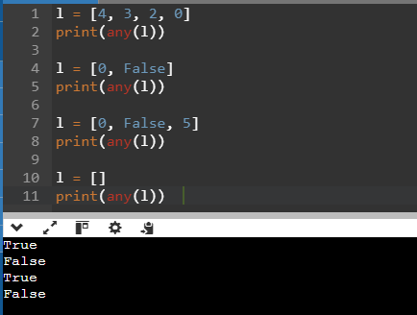

**Python float()**

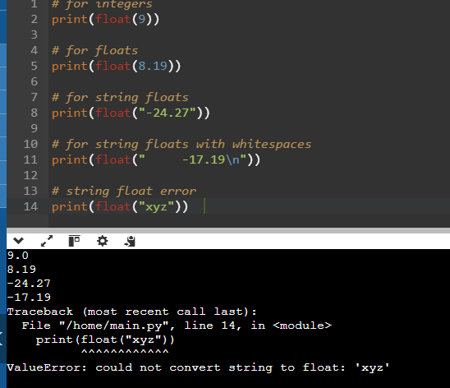

**Python format() Function**

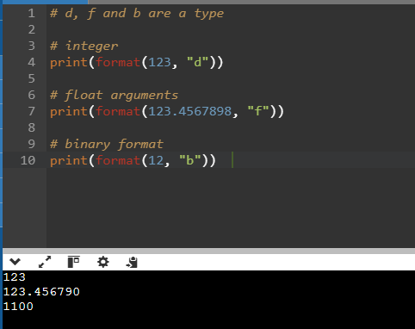

**Python hasattr() Function**

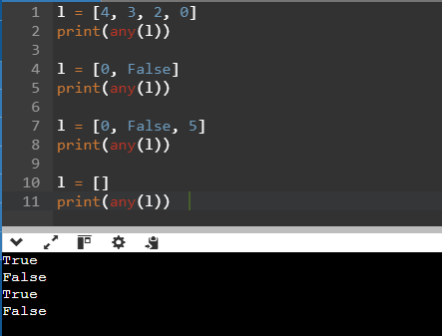

**Python iter() Function Example**

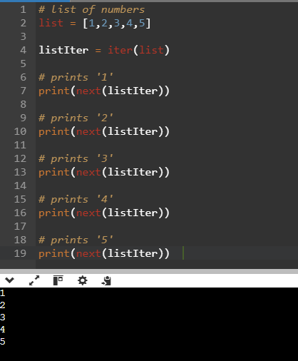

**Python len() Function**

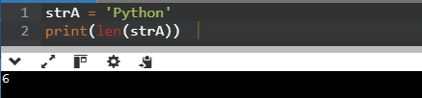

**Python list()**

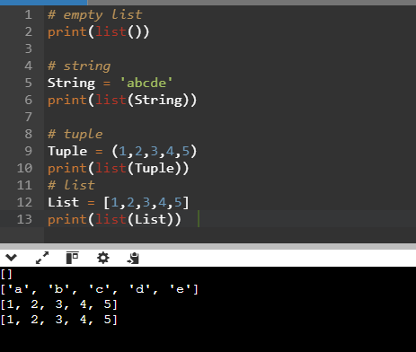

**Python memoryview() Function**

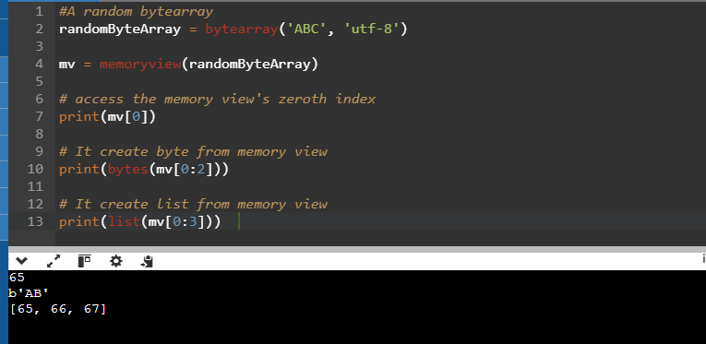

**Python object()**

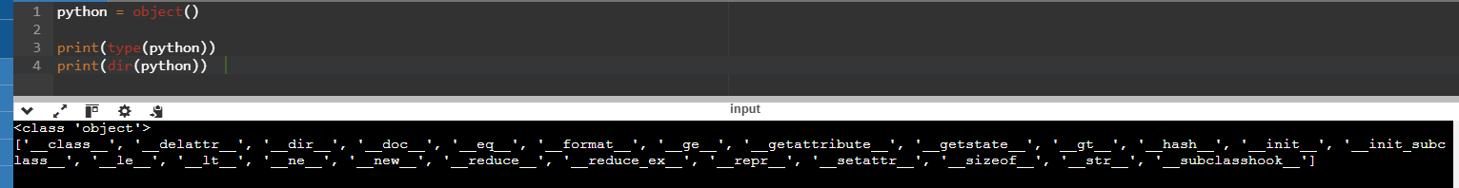

**Python hash() Function**

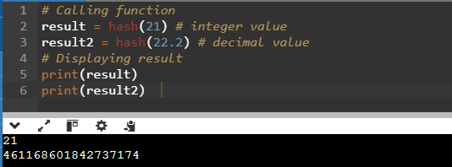

**Python pow() Function**

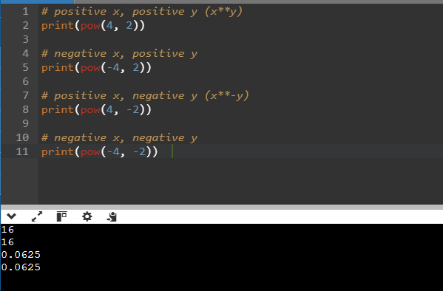

**Python reversed() Function**

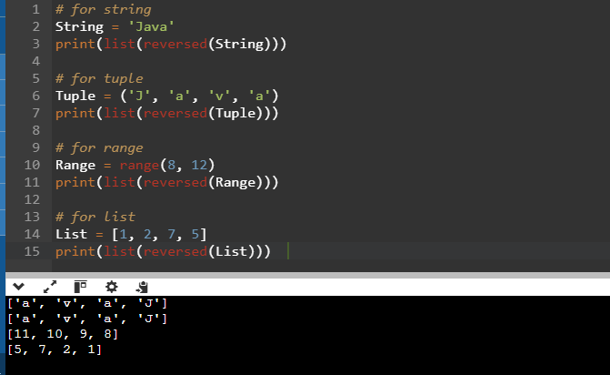

**Python issubclass() Function**

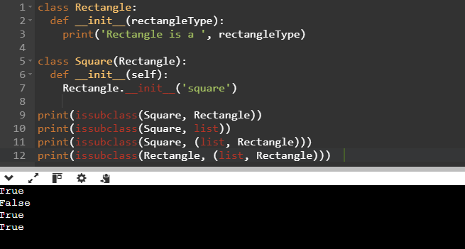

**Python tuple() Function**

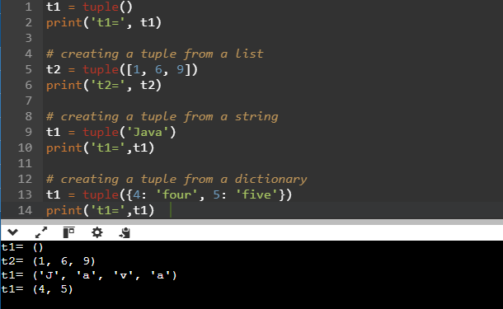

**Python zip() Function**

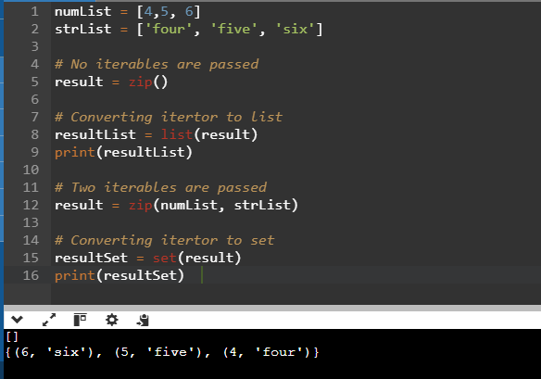

**Python Lambda Functions**

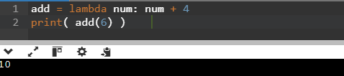

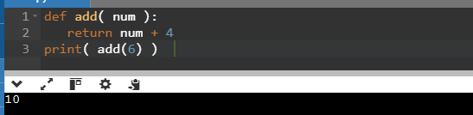

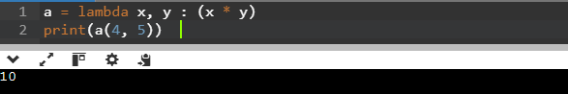

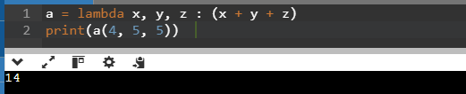

**What's the Distinction Between Lambda and Def Functions?**

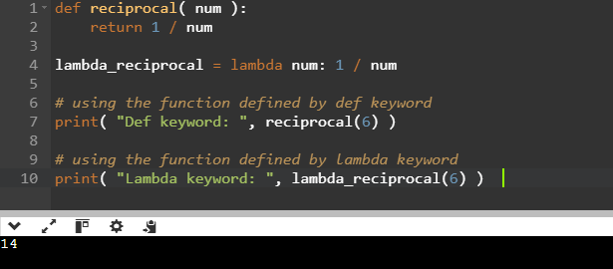

**Using Lambda Function with filter()**

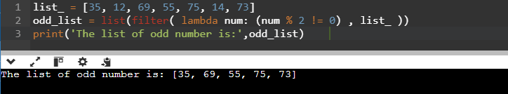

**Using Lambda Function with map()**

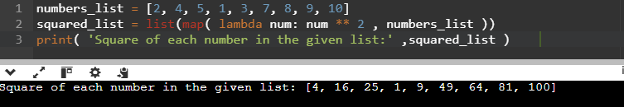

**Using Lambda Function with List Comprehension**

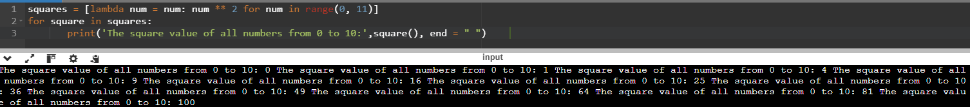**Using Lambda Function with if-else**

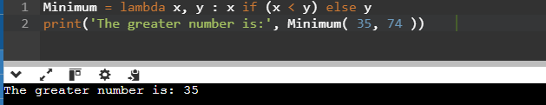

**Using Lambda with Multiple Statements**

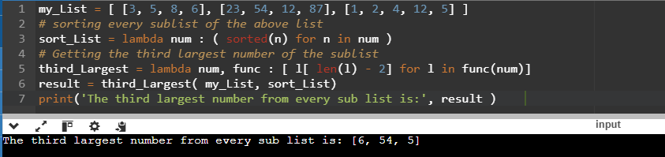

**Python Modules**

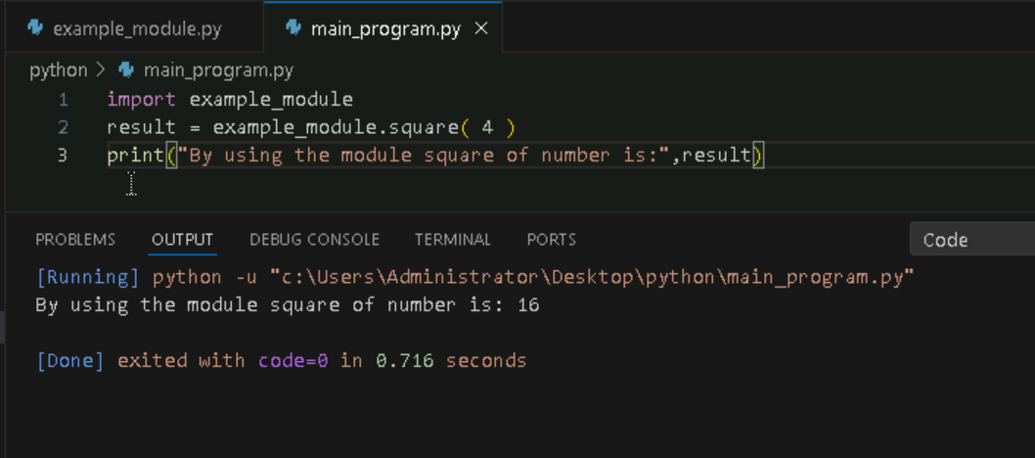

**Importing and also Renaming**

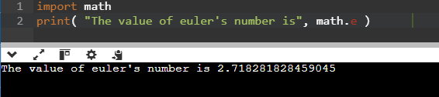

**Python from...import Statement**

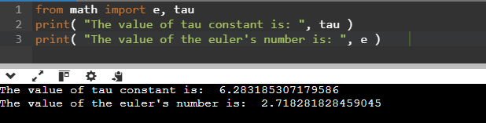

**Import all Names - From import * Statement**

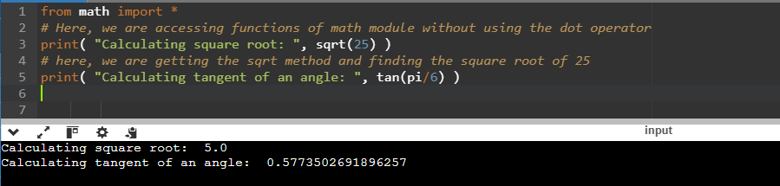

**Locating Path of Modules**



**The dir() Built-in Function**

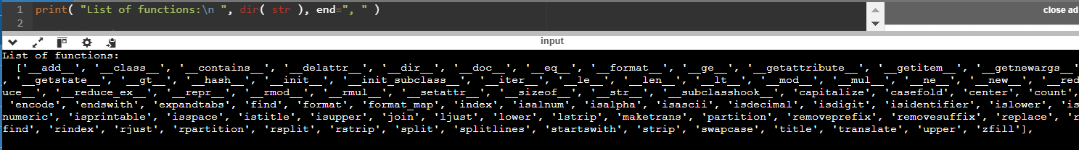

**Namespaces and Scoping**

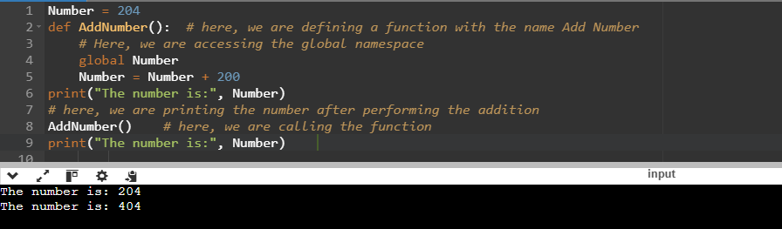

**PYTHON ARRAYS**

1. **Accessing array elements**

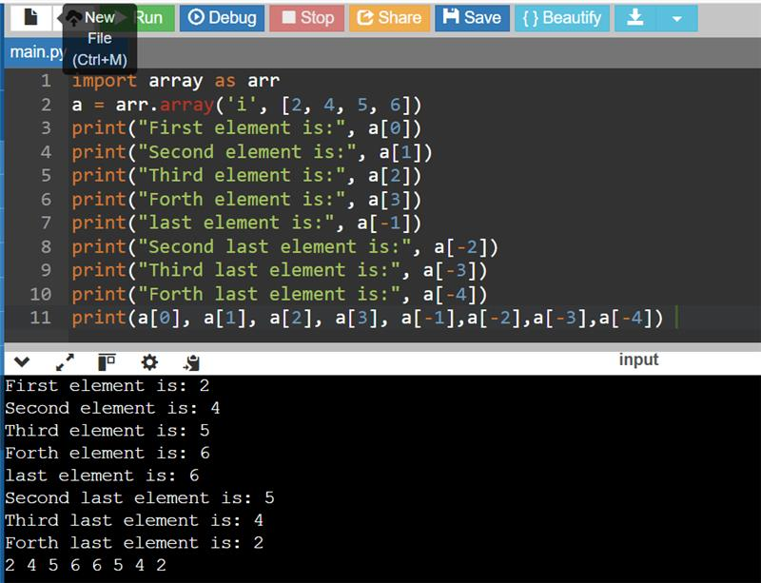

1. **Deleting the elements from Array**

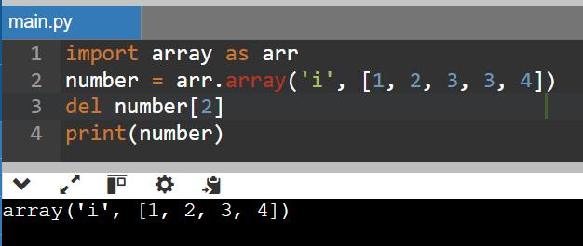

1. **Adding or changing the elements in Array**

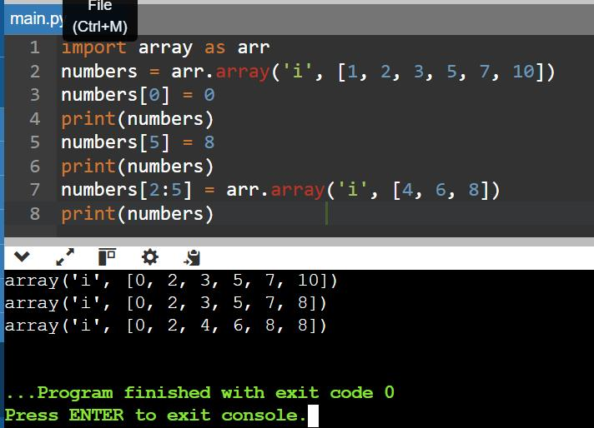

1. **To find the length of array**

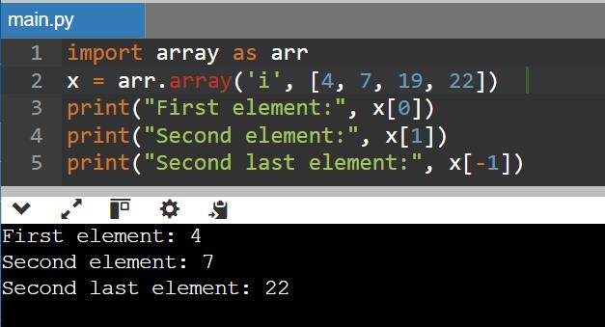

**Python Decorator**

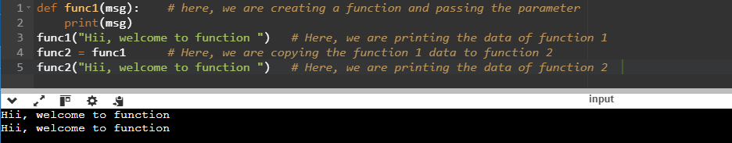

**Inner Function**

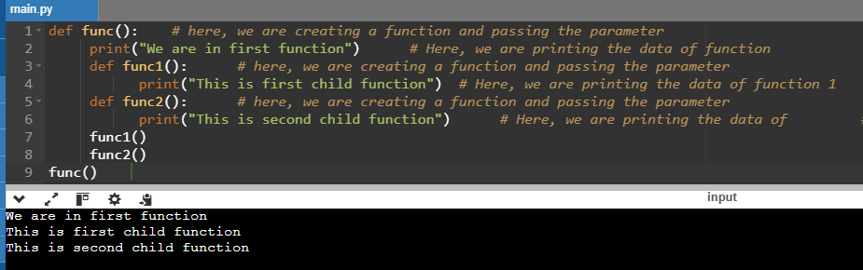

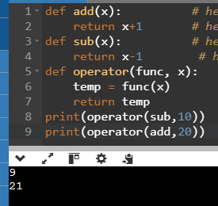

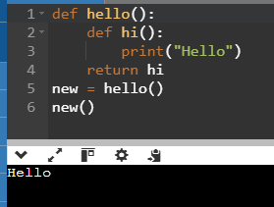

**Decorating functions with parameters**

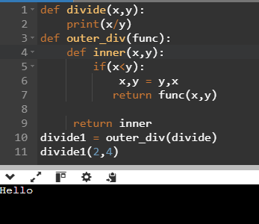

**Syntactic Decorator**

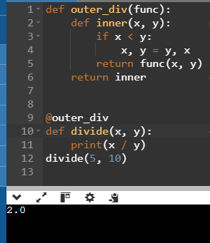

**Reusing Decorator**

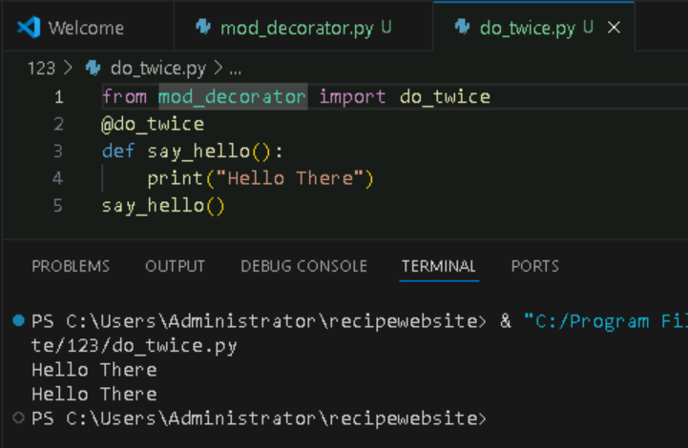

**Python Decorator with Argument**

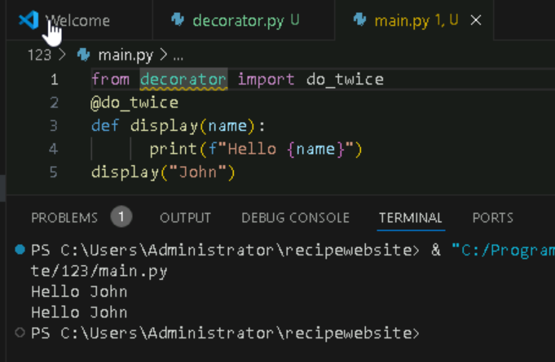

**Returning Values from Decorated Functions**

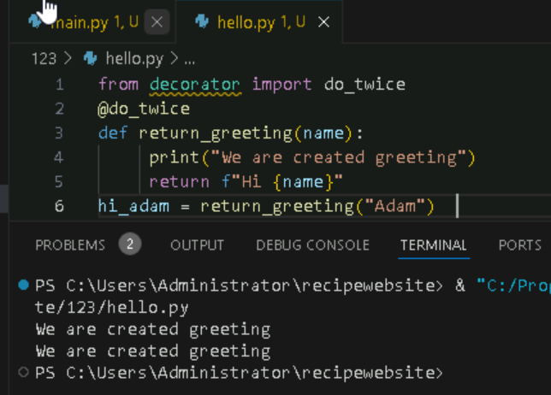

**Fancy Decorators**

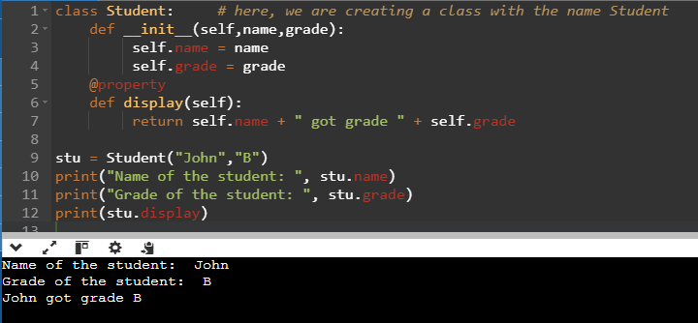

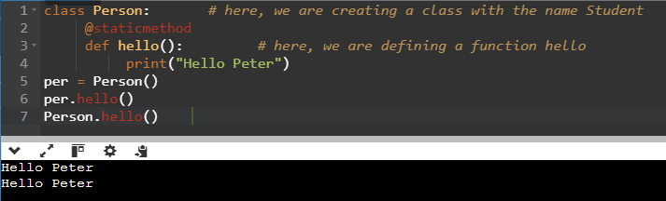

**Decorator with Arguments**

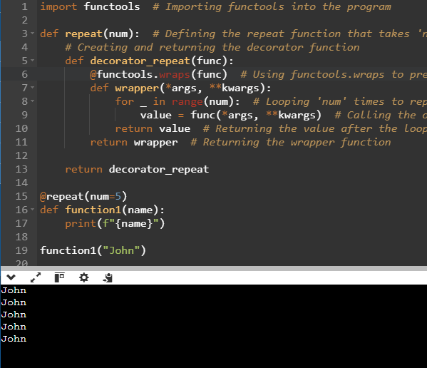

**Stateful Decorators**

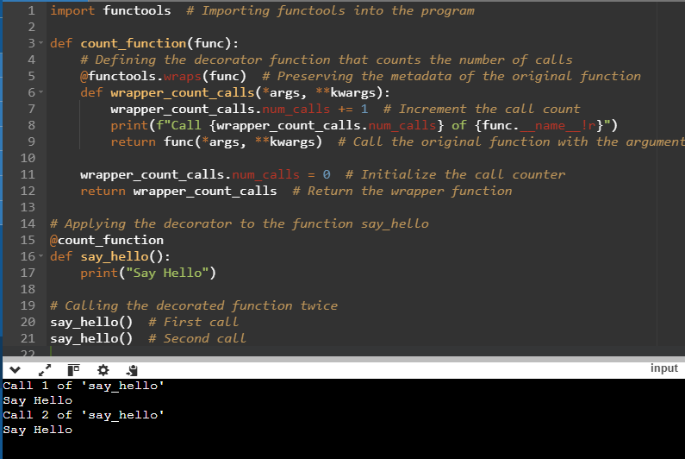

**Classes as Decorators**

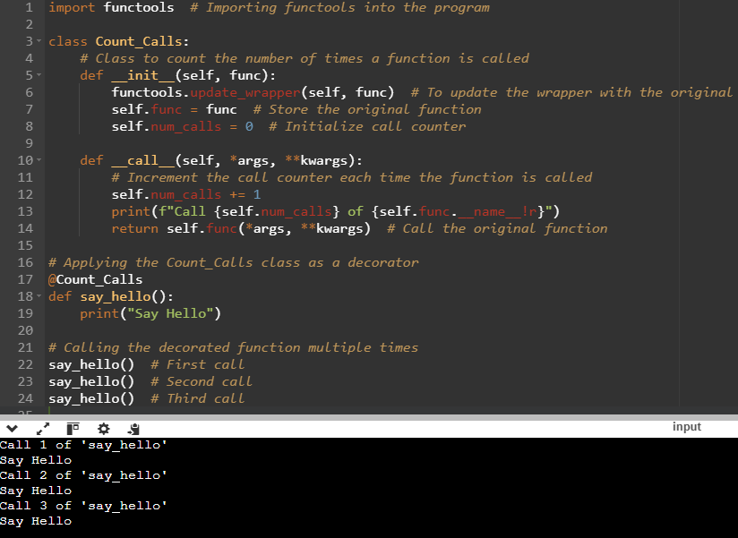

**Python Generators**

**How to Create Generator function in Python?**

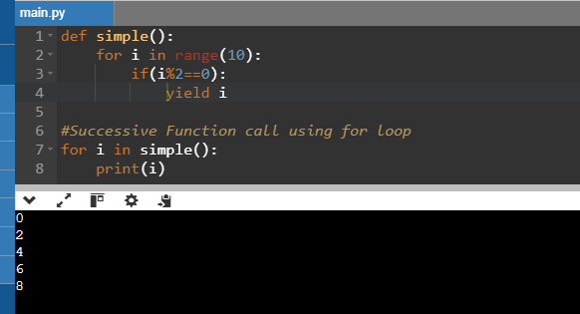

**yield vs. return**

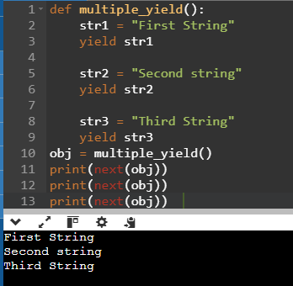

**Generator Expression**

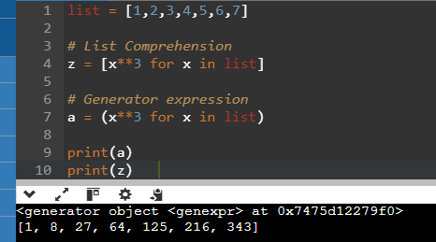

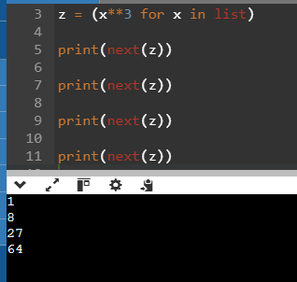

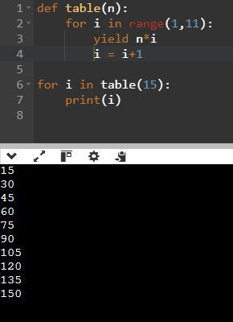

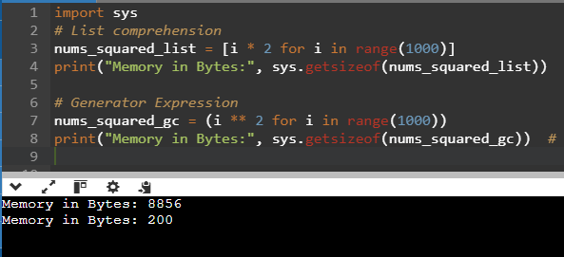

**Generate Infinite Sequence**

